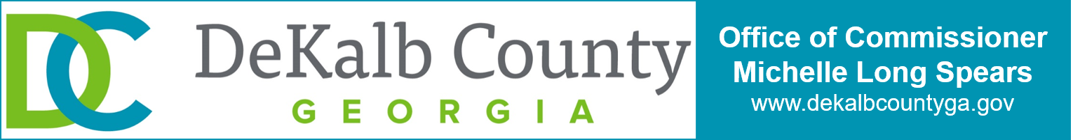

MEDIA CONTACT
Sonia Tyler
District 2
404-371-2863 (o)
404-922-6853 (c)
sstyler@dekalbcountyga.gov

FOR IMMEDIATE RELEASE:
March 18, 2024

UPDATE FINAL

Registration Now Open for Commissioner Spears’
State of DeKalb Animals (SoDA) Address and Luncheon
Alvin T. Wong, DeKalb County State Court Judge added to panel of experts

DECATUR, GA. – Commissioner Michelle Long Spears of DeKalb County’s District 2, in collaboration with the DeKalb Board of Commissioners, DeKalb administration, and a volunteer-led design team, announces that registration is open for the State of DeKalb Animals address and luncheon, scheduled for Wednesday, April 10, from 10:30 a.m. to 1:30 p.m. at the Historic DeKalb Courthouse in Decatur.

The SoDA initiative envisions an animal services system where every animal is safeguarded from abuse or neglect, and zero companion animals are left homeless. Grounded in the DeKalb County Animal Advisory Board’s “Common Sense Solutions: Plan for a Better Tomorrow,” adopted by the DeKalb Board of Commissioners last year, SoDA aims to create a future where no animal suffers due to violence or neglect.

Distinguished Emory University professor and bestselling author of “What it’s Like to be a Dog,” Dr. Gregory Berns will be serve as keynote speaker. Attendees will also have the opportunity to participate in a book signing in the lobby, where his book will be available for purchase.

Commissioner Spears will lead a panel discussion with subject matter experts, including:
- Animal Law Expert and Attorney Claudine Wilkins,
- UGA Professor Lisa Milot,
- Veterinarian and Social Justice advocate Gloria Dorsey, and
- DeKalb Sheriff Melody Maddox, and
- DeKalb State Court Judge Alvin T. Wong

The panel discussion will explore the connection between animal Problems and people problems, followed by a Q&A session with the audience.

-more-
Registration Now Open for Commissioner Spears’ State of DeKalb Animals (SoDA) Address and Luncheon, P. 2

“I’m honored to facilitate this critical conversation alongside such esteemed experts in their respective fields,” Commissioner Spears remarked. “Together, we’ll delve into the intricate relationship between animal challenges and societal well-being, forging a path toward a more compassionate, healthy, and harmonious community.”

Rebecca Guinn, CEO of LifeLine Animal Project, the nonprofit organization that manages the DeKalb County animal shelter, said, "LifeLine has been able to save more than 90 percent of the animals entering the DeKalb County shelter for several years, but we faced substantial challenges in 2023, with more people needing help, more animals entering the shelter, and fewer adopters and rescue partners to help get animals out of the shelter. The shelter can only serve as a band-aid for a community-wide problem. We are proud to partner with DeKalb County this year to provide greater access to care for pets in need and help keep pets and people together."

This event serves as the kickoff to a series of gatherings aimed at confronting and discussing the animal services challenges plaguing DeKalb County.

"We're thrilled to bring together DeKalb County's animal decision makers, advocates, and community members to address the pressing challenges facing our furry friends. Together, we're shaping a future where every animal is valued, protected, and loved," said Claudine Wilkins, animal law expert and attorney.

Seating is limited and registration is available on a first-come, first served basis.

For registration and additional information, visit https://bit.ly/SoDA_address.

###

Media Note:
About State of DeKalb Animals (SoDA): The State of DeKalb Animals initiative envisions a compassionate community in which every animal is valued, protected, and loved by fostering collaboration, innovative programming, and practical solutions.

Website: Visit www.michellelongspears.com to learn more about the State of DeKalb Animals address.

Social Media: Follow us on social media for updates on SODA and other DeKalb County news:
- www.facebook.com/CommissionerMichelleLongSpears
- www.instagram.com/CommissionerMichelleLongSpears

